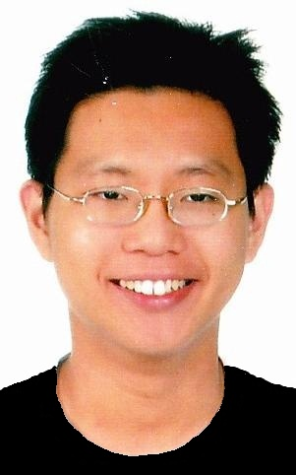
With an outgoing personality, and a desire to learn more, I am always ready
to provide a listening ear. I love to understand more about the world
through others' experiences. During my time with ACCA, I realise that there
isn't a lot of interactions between the students and even lecturers. As a
full-time student back then, I really hoped that there would be more time
to be spent with my ACCA peers, and grow together. The student union group
did organised many activities, but perhaps it didn't reach out enough to
students out there. I aim to join AISS and make this change.
I am someone who reads widely and has always been interested in the markets
and the events that are happening around us. Being young and energetic, I
am a people's person. I hope that along the way, I am able to meet up with
people of similar interests and come together to make ACCA a fun and
memorable time that all of us can have. Eventually, I hope a culture would
be built up and more people can spread the good words about ACCA; being a
fun and fufilling experience which is not only all about books and studying.
** **

Being able to meet up, connect with people, is something that I would love
to do. With such a passion, I believe that AISS is the best way to reach
out to people and make a change to other people's life.

